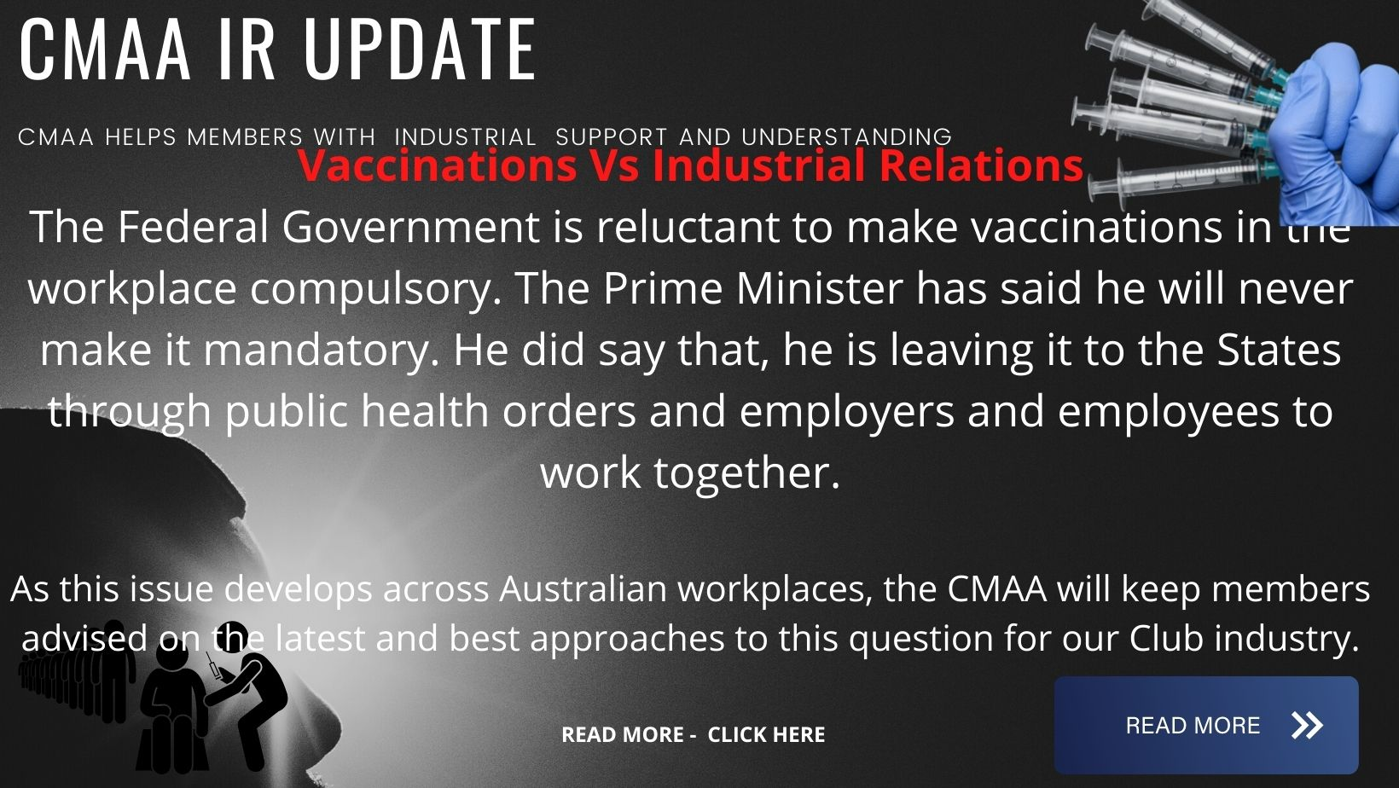

Vaccinations Vs Industrial Relations

The Federal Government is reluctant to make vaccinations in the workplace compulsory. The Prime Minister has said he will never make it mandatory. He did say that, he is leaving it to the States through public health orders and employers and employees to work together.

In relation to industrial relations this opens up a myriad of legal questions which unfortunately may have to be litigated before the courts before we get the right answers.

For example- There is a term implied in law in every contract of employment requiring an employee to obey the “lawful and reasonable directions” of their employer this is a basic fundamental element of all employment relationships.

The directive may be lawful but is it reasonable. In determining reasonableness, a Club may decide to have a Employee Immunisation Policy, as it is necessary to safe guard its members/patrons and employees as far as it is practicable to do so. This is also dependent on the type of workplace for example involving members of the general public not just immediate work colleagues.

The next question is the employers primary duty of care to its employees under Work Health and Safety Act, which requires a business or undertaking to ensure so far as practicable the health and safety at work of its employees. This duty is consequential when it comes to the risk of Covid-19 transmissions in the workplace, employee have equal obligations under the WH&S Act.

So far SPC the food canning company and Qantas (see details below) have advanced Mandating vaccination policy for their respective work forces.
ACTU secretary Sally McManus says there is "very broad" agreement across employer bodies, unions and governments that the best way to get Australian workers vaccinated is "through cooperation and consultation, not conflict."
"The only way to beat this virus is with the vaccine, we need to do everything we can to get people vaccinated, and the best way to do that is by working together.
"Division will cost us time we do not have.”

As this issue develops across Australian workplaces, the CMAA will keep members advised on the latest and best approaches to this question for our Club industry.

Qantas introducing compulsory vaccinations for all workers
Wednesday, August 18, 2021,
The Qantas Group will require all employees to be fully vaccinated against COVID-19 after receiving encouragement from a survey sent to 22,000 staff.
Chief executive Alan Joyce said in a statement today that frontline employees – including cabin crew, pilots and airport workers – will need to be fully vaccinated by November 15 and the other employees by March 31 next year.
He said there would "very rare" exemptions for those who are unable to be vaccinated for documented medical reasons.

